Assignment
1. Simple
=
2. Compound or shorthand
+=,-=, *=, /=, %=
a = 10
a = a + 10 ==> a+=10
b = 20
a = a + b ==> a +=b
&=, |=, ^=, >>=, <<=

Special
sizeof()

#include <stdio.h>

int main()
{
int a = 10;
int arr[10];
printf("%lu", sizeof(arr)); //%lu --> unsigned long int

return 0;
}
& Address
* indirection or dereference
. structure member accessing
-> structure pointer member accessing
, separator

Precedence Operator Description Associativity
1 ++ -- Suffix/postfix increment and decrement Left-to-right
() Function call
[] Array subscripting
. Structure and union member access
-> Structure and union member access through pointer
(type){list} Compound literal(C99)
2 ++ -- Prefix increment and decrement[note 1] Right-to-left
+ - Unary plus and minus
! ~ Logical NOT and bitwise NOT
(type) Cast
* Indirection (dereference)
& Address-of
sizeof Size-of[note 2]
_Alignof Alignment requirement(C11)
3 * / % Multiplication, division, and remainder Left-to-right
4 + - Addition and subtraction
5 << >> Bitwise left shift and right shift
6 < <= For relational operators < and ≤ respectively
> >= For relational operators > and ≥ respectively
7 == != For relational = and ≠ respectively
8 & Bitwise AND
9 ^ Bitwise XOR (exclusive or)
10 | Bitwise OR (inclusive or)
11 && Logical AND
12 || Logical OR
13 ?: Ternary conditional[note 3] Right-to-left
14[note 4] = Simple assignment
+= -= Assignment by sum and difference
*= /= %= Assignment by product, quotient, and remainder
<<= >>= Assignment by bitwise left shift and right shift
&= ^= |= Assignment by bitwise AND, XOR, and OR
15 , Comma Left-to-right

#include <stdio.h>

int main()
{
int a = 10;
// a *= 20 - 10; //
a = a * 20 - 10;
printf("%d", a);

return 0;
}

#include <stdio.h>

int main()
{
int a;

a = 10,20,30;

printf("%d", a);

return 0;
}

#include <stdio.h>

int main()
{
int a;

a = (10,20,30);

printf("%d", a);

return 0;
}

#include <stdio.h>

int main()
{
int a = 10;
a = !!!a;
printf("%d", a);

return 0;
}

#include <stdio.h>
#include <limits.h>
int main()
{
short int a; // or signed short int or signed short
printf("%lu\n", sizeof(a));
printf("%d - ", INT_MIN);
printf("%d", INT_MAX);

return 0;
}

#include <stdio.h>

int main()
{
printf("%lu\n", sizeof(short int));
printf("%lu\n", sizeof(int));
printf("%lu\n", sizeof(long int));
return 0;
}

eywords or Reserved Words --> ANSI C --> 32

Datatypes 12
standard
char, int, float, double, void
qualifier
signed, unsigned, short, long
Modifier
const, volatile
sizeof()
Control Flow Statements 11
Selective
if, else, switch, case, break, default
Iterative
for, while, do, continue, goto
UDD (User Defined Datatype 4
struct, union, enum, typedef
Storage Classes 4
auto, register, static, extern
Function 1
return

Data types
char 1

int 4
short int --> 2 bytes
long int --> 8 bytes
long long int

float 4
double 4
void

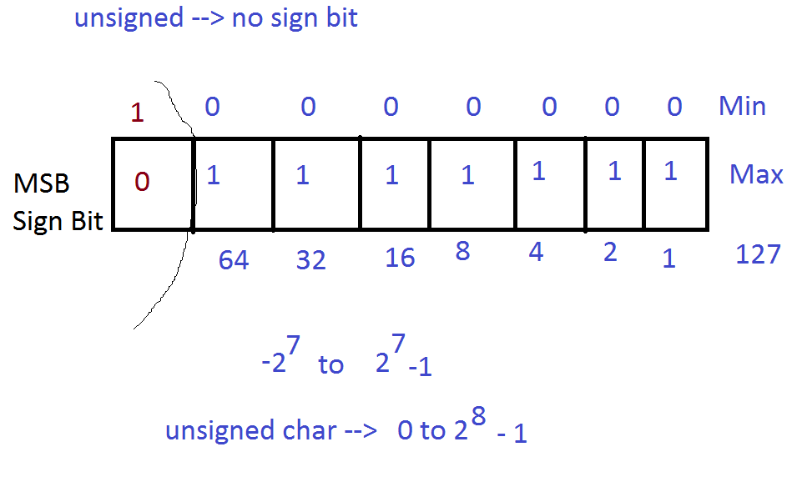

ASCII --> Character encoding format

1. Standard --> 0 to 127
2. Extended --> 128 to 255

Structure of C
<documentation_section>
/*
Program to Calculate Simple interest
Author : Aasaithambi Jay
Date : 01/12/2022
*/
<Preprocessor_directives>
#include

<definition_section>
#define --> macro definition

<global_declaration>
int total = 20;

int main(){
<local_declaration>
<executable_statement>
return 0;
}

//Program to calculate simple interest

#include <stdio.h>

int main()
{
int principle;
float time, rate_of_interest, simple_interest;
printf("Principle Amount : ");
scanf("%d", &principle);
printf("Rate of Interest : ");
scanf("%f", &rate_of_interest);
printf("Time : ");
scanf("%f", &time);

//Calculating simple Interest
simple_interest = principle * time * rate_of_interest / 100;

printf("Simple Interest : %.2f", simple_interest);

return 0;
}
/*
Format specifier
%c --> signed char or unsigned char
%d or %i --> signed int or int
%hd or %hi --> signed short int
%hu --> unsigned short int
%ld or %li --> signed long int or long int
%lld --> singed long long int
%lu --> unsigned long int
%llu --> unsigned long long int
%f --> float

%lf --> double
%Lf --> long double

*/

